Summer Showroom
28 June 2023

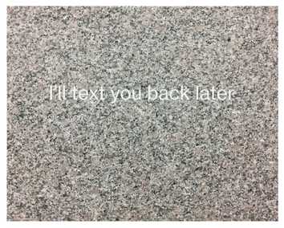 | Morten Søndergaard  I'll text you back later, 2017  Marble  50 x 100 cm | DKK 16,000.00
 | Neda Zarf Saz  SUNRISE, 2020  Wooden bar, photographs, paint, threads, resin  174 x 2 x 2 cm | DKK 6,500.00
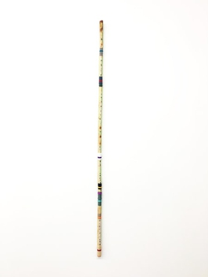 | Neda Zarf Saz  THE ROAD, 2020  Wooden bar, photographs, paint, threads, resin  169 x 2 x 2 cm | DKK 6,500.00
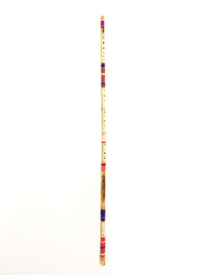 | Neda Zarf Saz  MEADOW, 2020  Wooden bar, photographs, paint, threads, resin  158 x 2x 2 cm | DKK 6,500.00
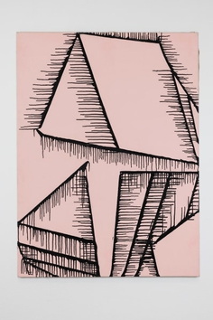 | Gunnar Aagaard Andersen *  DRIVEBILLEDE, 1966  Oil on canvas  130 x 97 cm | DKK 80,000.00
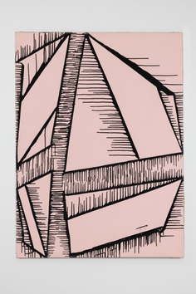 | Gunnar Aagaard Andersen *  DRIVEBILLEDE, 1966  Oil on canvas  130 x 97 cm | DKK 80,000.00
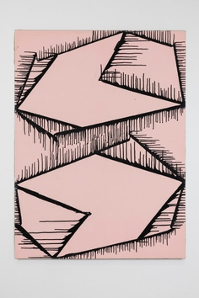 | Gunnar Aagaard Andersen *  DRIVEBILLEDE, 1966  Oil on canvas  130 x 97 cm | DKK 80,000.00
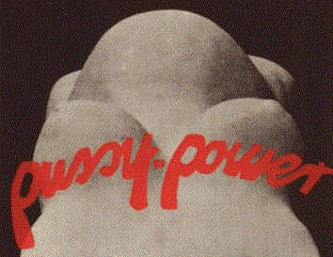 | Kirsten Justesen  Pussy Power (edition of 25), 1969-71/2000  Archival print on Somerset cotton paper  41 x 52 cm | DKK 15,000.00
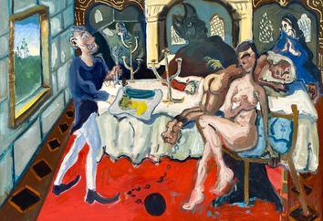 | Dan Schein  Fun and Games, 2021  Oil on canvas  132 x 195 cm | DKK 70,000.00
 | Dan Schein  ENYA in her Castle Writing Beautiful Poetry , 2022  Oil on canvas  55 x 70 cm | DKK 32,000.00
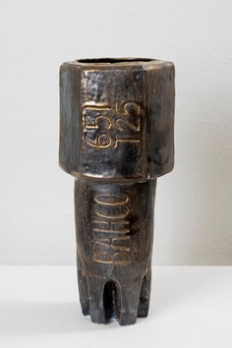 | Inger Sif Heeschen  Torx2000 Basic Bits, 2019  glazed stoneware  31 cm | DKK 6,500.00
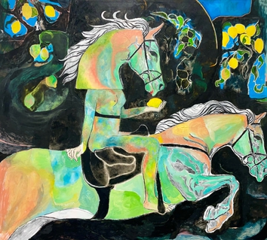 | Mie Mørkeberg  Fly By, 2023  Oil and acrylic on canvas  170 x 190 cm | DKK 120,000.00
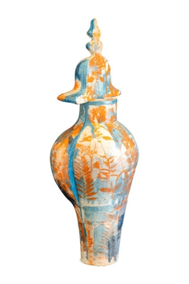 | Inger Sif Heeschen  Delft Double , 2022  Glazed stoneware with underglaze and serigraph print  85 cm | DKK 20,000.00
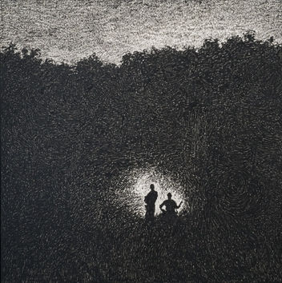 | Ahmad Siyar Qasimi  Lygtefører, 2023  Oil stick on paper  140 x 140 cm | DKK 65,000.00
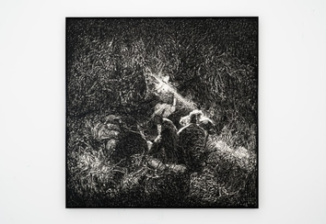 | Ahmad Siyar Qasimi  Fangeleg, 2023  Oliestift på papir  140 x 140 cm | DKK 65,000.00
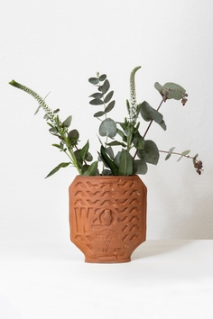 | Inger Sif Heeschen  Downtown Digging - Drainspotting London Collection, 2021  Ceramics  21 x 15 cm | DKK 4,000.00
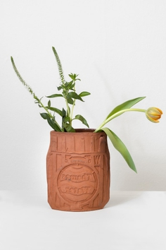 | Inger Sif Heeschen  Downtown Digging - Drainspotting London Collection, 2021  Ceramics  21 x 15 cm | DKK 4,000.00
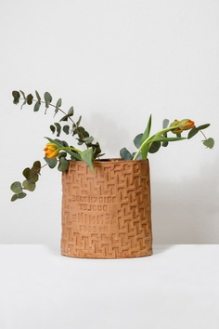 | Inger Sif Heeschen  Downtown Digging - Drainspotting London Collection, 2021  Ceramics  26 x 23,5 cm | DKK 7,000.00
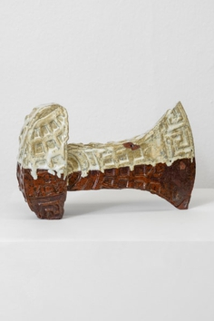 | Inger Sif Heeschen  Battle Of Ages, 2021  Ceramics  32 x 20 cm | DKK 6,000.00
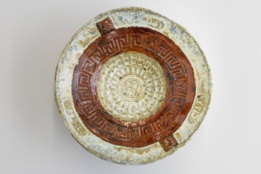 | Inger Sif Heeschen  Drainspotting - Copenhagen Collection, 2021, 2021  Ceramics  30 x 10 cm | DKK 8,000.00
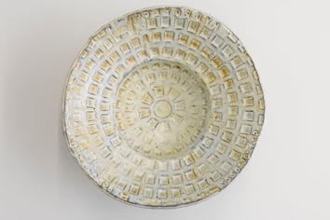 | Inger Sif Heeschen  Drainspotting - Copenhagen Collection, 2021, 2021  Ceramics  32 x 12 cm | DKK 8,000.00
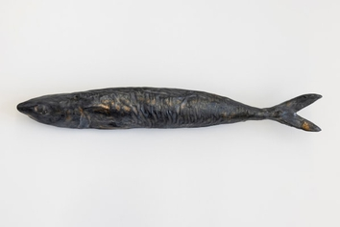 | Inger Sif Heeschen  Sild, 2023  Glazed ceramics  35 x 3,5 cm | DKK 3,500.00

